Chapter 1.

1. Describe the difference of compiler and interpretor
2. What is the internal structure of a typical compiler

Chapter 2.

1. What is a token, scanner
2. REs, FA, DFA, NFA

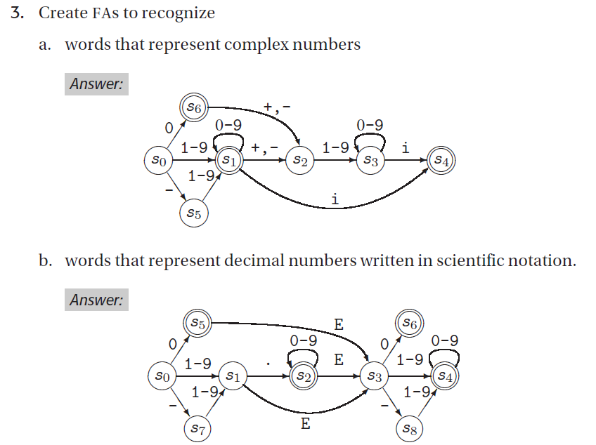

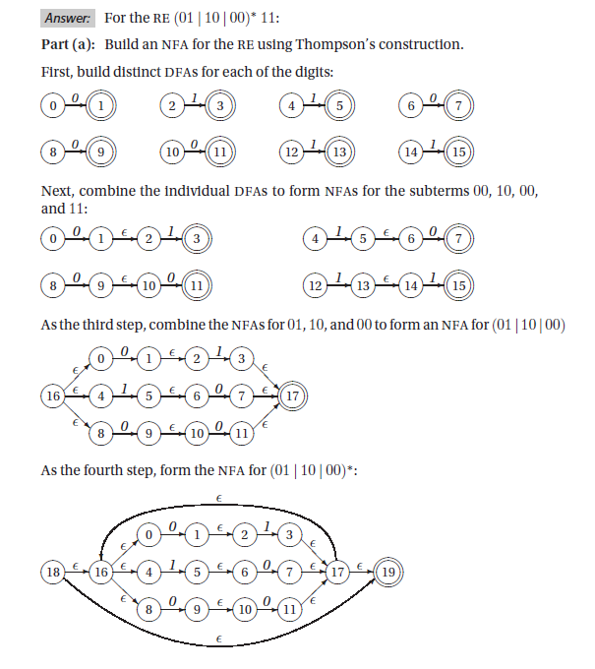

**7.c**

